**F3K Program for FrSky Taranis  
QX7 and XD9 Transmitters**

Jesper Frickmann

March 13, 2018



Contents

Overview 3

Installation 3

Telemetry setup 4

Model setup 5

Flying 6

Altimeter 7

Timing and score keeping 7

Graphing of log data 8

If you deleted the telemetry sensors 8

Cheat sheet 9

Logical Switches 10

Mixers 11

# Overview

This program provides the following features:

* Timing and score keeping for all of the official FAI F3K tasks.
* Scores can be saved to the SD card and viewed later. That way, you can fly a self-timed contest and record scores on paper afterwards.
* Graphing of telemetry log data. You can view e.g. receiver battery volts, RSSI signal strength and, if you have an altimeter, altitude and vertical speed.
* Controls and mixes: flaps, camber control, ailerons, aileron differential, aileron-to-rudder, snap flaps, flap-to-elevator, and flight modes.
* Zoom flight mode is entered after the Launch mode, to facilitate a straight climb-out.
* Flaps are disabled at launch, and remain disabled until the throttle stick is pushed forward, for quick turnaround.
* Optimal usage of the flaperon servo range by having full flaps be 100% servo down, and aileron up without flaps and camber be 100% servo up.
* Full aileron control at any flap position by reducing flaps, if needed to allow for the desired aileron response.
* Camber preset for each flight mode is adjusted with the throttle trim button.
* Mixes for snap flap, flap-to-elevator, aileron differential, and aileron-to-rudder can easily be adjusted with trim buttons.
* Flaperon travel can be adjusted on five-point curves, and the curves can be easily adjusted with the aileron trim button at each of the five points, to get perfect alignment of the flaperons.
* Channels can easily be moved around, and servo directions, centering, and end points set with the channel configurator.

# Installation

**Sometimes, the telemetry menus crash the first time they are opened. Just cycle power on your radio, and it should work then. Lua errors do not affect control of the plane.**

**If the problem persists, then it is probably because the “luac” option was not selected before downloading the firmware and flashing the radio, as described below.**

First of all, your transmitter must be updated to firmware version 2.2, and have the “lua” and “luac” build option checked. Open Companion, go to Settings, and check “lua” and “luac”:

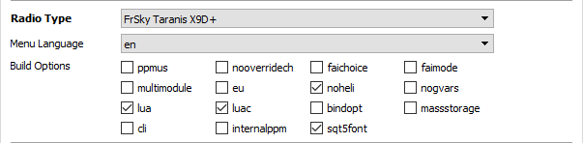

Then click Download and Check for Updates. Save the firmware, and click Write Firmware to Radio.

Next, copy the files from the SD folder in the Zip file over to your radio’s SD card. Drag the entire SCRIPTS and IMAGES folders over, and merge the files into the existing folders on your radio’s SD card. If prompted, select overwrite existing files.

The following script should be saved in /SCRIPTS/FUNCTIONS:

* JFutil.lua

The following script should be saved in /SCRIPTS/MIXES:

* JF3K.lua

The following scripts should be saved in /SCRIPTS/TEMEMETRY:

* JF3Ksk.lua
* JF3KskLd.lua
* JF3Ksb.lua
* JF3KsbLd.lua
* JFgrph.lua
* JFgrphLd.lua
* JF3Kcf.lua
* JF3Kch.lua (RE only)
* JFchannels.lua
* JF3Kalign.lua
* JF3Kcenter.lua
* JF3Kadjmix.lua

The following image file should be saved in /IMAGES:

* Lua-girl.bmp

Finally, copy the radio program from the Zip file over to your radio:

* Open Zip file .OTX for the right transmitter in Companion.
* Read models and settings from your own radio.
* Drag the “JF F3K” model over from the Zip file .OTX to your own .OTX file.
* Write models and settings to the radio from your own .OTX file.

# Telemetry setup

|  |  |
| --- | --- |
| The program uses receiver battery voltage, altitude, and flight mode (FM) internally. In order to avoid that things get messed up when you configure the sensors for your plane, I have created the calculated sensors “RBat”, “Alti”, and “FM”. |  |

**Do not delete these three sensors! If you did it anyway, please read the section “If you deleted the telemetry sensors” later in this document.**

Dive into the TELEMETRY menu and select “Discover new sensors”. Then set the sources for “RBat” and “Alti” to the actual sensors.

|  |  |
| --- | --- |
| Edit the “RBat” sensor, and set Source 1 to “RxBt” (or “A1” in some cases).  If you need to change the battery voltage warning threshold, then do so in logical switch line L09. |  |
| If you have an altimeter, then edit the “Alti” sensor, and set Source 1 to “Alt”.  Also set Source under Variometer to “VSpd” (find it below sensors in the TELEMETRY menu). |  |
| Enable logging for the relevant parameters (e.g. “RSSI”, and possibly “VSpd”). |  |

# Model setup

All global variables should be changed by the menus below; there is no need to change global variables directly. If you want to re-assign switches, then do so under logical switches. Please refer to “Logical switches” below, to see where to change the respective switches.

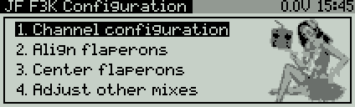Now that the receiver is bound, and telemetry has been set up, it is time to dive into the configuration menus. Two long presses on the PAGE button will get you to telemetry screen #4. This screen is a menu with four different sub-menus.

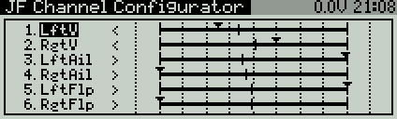The first sub menu is the Channel Configurator. The small black triangles show the current servo positions. Use ± or Rotary to select a channel. Press ENTER to edit. Use ± or Rotary to select what to edit for the channel. Press ENTER again to edit (selection is blinking). The following items can be edited.

1. Channel number. This moves the channel up or down on the list.
2. Servo direction.
3. The entire servo interval. This keeps the center point in the middle between min. and max. and moves all three points up or down. If necessary, the interval is scaled to avoid exceeding ±125%.
4. Servo end points. Adjusts the range while keeping the end points symmetrical around the center.
5. Minimum point.
6. Center point.
7. Maximum point.

Press EXIT when you are done.

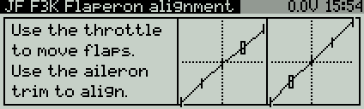The second menu is for aligning the 5-point output curves for flaperon servos between the left and right sides. Use the throttle stick to move between the five points, and aileron trim to align the flaperons at each point.

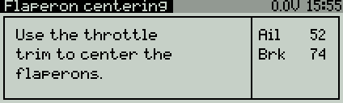The third menu is for setting air brake and aileron travels. Use throttle trim to adjust the flaperons to the position of maximum reflex. For most models, maximum reflex is where the flaperons are flush with the trailing edge of the wing. Flaps can travel from this position to 100% down. Ailerons use up the remaining servo movement.

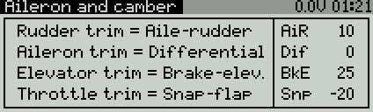The fourth and last menu is for adjusting various mixes.

If you want additional camber on a slider, then set it up under Input 6: Cmb, by changing the input source from MAX to the desired slider.

# Flying

Hold the launch switch F when you throw the plane, to activate the Launch flight mode, Flaps are hereby disabled, and the radio yells “Flaps up”. Re-enable flaps, and make the radio shut up, by moving the throttle stick all the way forward again. This feature helps you come in for a quick relaunch without having to worry about flaps being down during the launch.

After the launch switch is released, the Zoom flight mode takes over. The plane should be trimmed for a nice straight climb-out in this mode. When you move the right stick to push over for level flight, the Zoom mode is ended.

When gliding, the three flight modes Float, Cruise, and Speed can be selected with switch B. Camber and elevator can be trimmed for each flight mode individually.

# Altimeter

If you have an altimeter sensor connected to your receiver, then the program can report your launch height and the current altitude. The altimeter is reset every time you pull the launch switch. The launch altitude is reported 3 sec. after leaving Zoom mode, when switch A is either up or down. The variometer sound is turned on, when switch A is down. The current altitude is reported when switch H is pulled down and switch A is either up or down.

**When flying contests, you are not allowed to have altitude feedback. Therefore, switch A should be centered during contests.**

# Timing and score keeping

Timing and score keeping is available for all of the 11 official F3K tasks, a “Quick Relaunch” task, and a “Just Fly” task. Long press PAGE to enter the telemetry screens. Timing and score keeping is on the first telemetry screen.

Select the task with ± or rotary. Press ENTER to start the window timer. When the window is running, then the flight timer is controlled by the launch switch. There are two different modes for the flight timer:

* In normal mode, you pull and release the launch switch to start the flight timer, and pull and release again to stop the timer.
* In QR (Quick Relaunch) mode, the flight timer is stopped and started immediately again every time you pull and release the launch switch. You toggle QR by pressing + or Rotary right while the window timer is running.

There is a 5 sec. "grace period" after the flight timer is started. So if you pull and release the launch switch by mistake, then just pull and release again immediately to cancel. If you land off the field, and need to score a zero, then do a long press on the MENU button instead of pulling the launch switch, to stop the timer.

When the EoW (End of Window) option is selected, then the flight timer freezes as the task window ends. That way, you do not overfly the task window, and you can decide whether to keep the score by pulling the launch switch, or score a zero by long pressing the MENU button, after you have landed. EoW is toggled by pressing - or Rotary left when the window timer is running.

In the Poker task, use the two rotary knobs S1 and S2 to set minutes and seconds, respectively. When your first attempt has been started, then you must make your called time before moving on!

The Quick Relaunch task is meant to practice fast turnaround. The QR option is selected by default, and you set the target time with S1 and S2 as for Poker.

The window timer is stopped automatically when a task is complete, but you can also stop and restart the window timer by pressing ENTER when the flight timer is not running. To reset the scores, change task when the window timer is stopped. If you have made scores, then you will be prompted to save to the SD card before changing task.

To view the scores that have been saved to the SD card, go to the second telemetry screen by pressing PAGE. Use ± or Rotary to browse the saved scores. If you see the text “Log getting too large” flashing, then it is time to delete all, or some, of your log file located in “/LOGS/JF F3K Scores.csv”, before you run out of memory.

# Graphing of log data

The third telemetry screen is a graph of log data. Use ± or Rotary to change the flight, press ENTER to change the parameter being plotted, and press MENU to view summary statistics.

Data for the current model on the same day is shown. If you want to look at yesterday's file, then you must either set back the date on your radio, or rename the file in the transmitter’s SD CARD menu.

Individual flights are identified by time gaps and by the flight mode sensor “FM” being equal to 1 for Launch mode. If there is a problem with identifying the flights correctly, then please check that the FM sensor is working correctly, and that its data is being recorded.

# If you deleted the telemetry sensors

If you accidentally deleted the three telemetry sensors that were set up in the program, then you will need to recreate them.

“Rbat” is a calculated sensor. Set “RxBt” or “A1” as the first source. It is used the following places in the program: L09, L10, SF4, and in the Top Bar under the DISPLAY menu.

“Alti” is also a calculated sensor. Set “Alt” as the first source if you have an altimeter, and check Auto Offset. It is used in SF6, SF7 (Alti+), SF8, and the Top Bar.

“FM” is a custom sensor, and it must have Id 5050. Check Logs at the bottom of the screen. Otherwise, the graphing screen may not properly identify the individual flights. The FM sensor is updated by the function script JFutil.lua.

# Cheat sheet

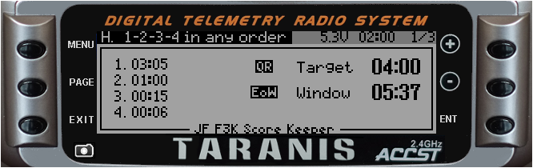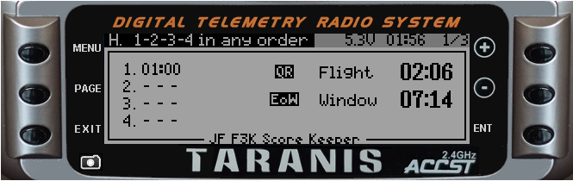

**Timing and score keeping - window timer is not running:**

Change F3K task

(Prompt to save scores)

Start window timer

**Timing and score keeping - window timer is running:**

Toggle QR

Stop window timer

(Flight timer not running)

Toggle EoW

Stop flight timer

and score a zero

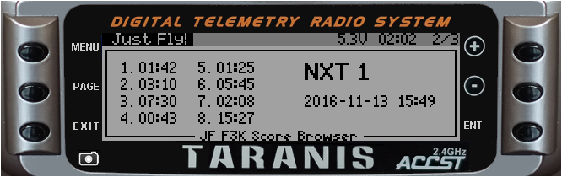

Browse scores

**Score browsing:**

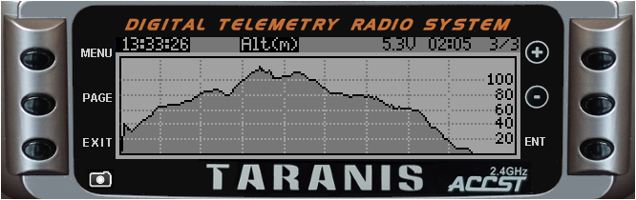

Browse flights

Change parameter

Show stats

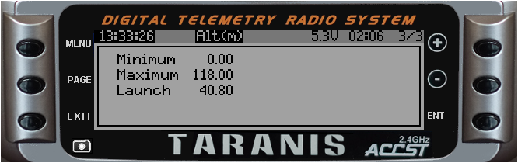

Browse flights

Change parameter

Show graph

**Graphing:**

**Show stats:**

# Logical Switches

## Switch assignment

|  |  |  |
| --- | --- | --- |
| L1 | !SA- AND L29 | Switch allowing altitude announcement  (should be off during contests). |
| L2 | SA↓ AND ---- | Variometer switch. |
| L3 | SB↑ AND ---- | Switch for speed flight mode. |
| L4 | SB↓ AND ---- | Switch for float flight mode. |
| L5 | !SD- AND ---- | Data logging switch. |
| L6 | SF↓ AND ---- | Trigger switch for launch and timer stop. |
| L7 | SH↓ AND L01 | Switch for announcing current altitude every 15 sec. |

## Battery voltage alarm

|  |  |  |
| --- | --- | --- |
| L9 | TELE1:RBat < 7 | Low voltage alarm threshold for receiver battery. |
| L10 | TELE1:RBat > 0 | Battery voltage sensor connected (don’t alarm all the time!) |
| L11 | ( L09 AND L10 ) AND !L12 | Battery low voltage alarm. |
| L12 | Sticky(L11, ----) Duration(25s) Delay(0.1s) | Take a 25 sec. break before repeating the alarm. |

## Zoom flight mode

|  |  |  |
| --- | --- | --- |
| L14 | |d(Ail)| > 6 | Aileron stick is being moved. |
| L15 | |d(Ele)| > 6 | Elevator stick is being moved. |
| L16 | L14 OR L15 | Right stick is being moved. |
| L17 | Sticky(FM1, L16) | Zoom flight mode (lower priority than Launch). |

## Disable air brake

|  |  |  |
| --- | --- | --- |
| L19 | ( I4:Brk > 90 ) AND !FM1 | Stick up: re-enable airbrake. |
| L20 | Sticky(FM1, L19) | Air brake disabled. |
| L21 | ( !FM1 AND L20 ) AND !L19 Delay(3s) | “Flaps up” warning. |
| L22 | L20 OR L44 | Also disable air brake when centering flaperons. |

## Timer control

|  |  |  |
| --- | --- | --- |
| L24 | LUA1a = 1 | LUA1a = WTmr controls the window timer. |
| L25 | LUA1b = 1 | LUA1b = FTmr allows flight timer to run. |
| L26 | ( Edge(L06, [0:0]) ) AND L25 | Trigger switch released and flight timer allowed to run. |
| L27 | Edge(!L06, [0:0]) | Trigger switch pulled. |
| L28 | !L25 OR L27 | FTmr is off or the trigger switch is being pulled. |
| L29 | Sticky(L26, L28) | Flight timer is running. |

## Altitude announcement

|  |  |  |
| --- | --- | --- |
| L31 | Edge(!FM1, [0:0]) | Launch mode activated – reset altimeter. |
| L32 | FM1 OR FM2 | Launch or Zoom mode active. |
| L33 | Sticky(L32, L34) | Active during Launch, Zoom and another 3 sec. |
| L34 | !L32 AND L33 Delay(3s) | 3 sec. pause after end of Zoom. |
| L35 | ( Edge(L33, [0:0]) ) AND L01 | Announce launch height 3 sec. after end of Zoom. |

## Data logging

|  |  |  |
| --- | --- | --- |
| L37 | ( LUA1b > 0 ) AND L05 | Timer running and switch is on for data logging. |
| L38 | L37 AND L33 | Fast data logging during Launch and Zoom. |
| L39 | L37 AND !L33 | Slow data logging during gliding. |

## Adjustment modes

|  |  |  |
| --- | --- | --- |
| L41 | LUA1c = 1 | LUA1a = Adj = 1: align flaperon output curves. |
| L42 | LUA1c = 2 | LUA1a = Adj = 2: adjust airbrake and aileron travels. |
| L43 | LUA1c = 3 | LUA1a = Adj = 3: adjust aileron-rudder, differential, brake-elevator, and snap-flap mixes. |
| L44 | L41 OR L42 | Disable aileron and camber for these two adjustment functions. |

# Mixers

|  |  |  |
| --- | --- | --- |
| CH1:Rudd | I1:Rudd Weight(+100%)  += I3:Aile Weight(+GV3:AiR) NoTrim [AilRud] | Rudder. |
| CH2:Elev | I2:Elev Weight(+100%)  += CH26:Brake Weight(-GV5:BkE) Offset(GV5:BkE) Curve(CV3:BrF) [BrkEle] | Elevator. |
| CH3:Left | I3:Aile Weight(+GV1:Ail) Switch(!L44) Diff(-GV4:Dif)  += CH32:Flap Weight(-100%) | Left flaperon. |
| CH4:Right | I3:Aile Weight(+GV1:Ail) Switch(!L44) Diff(GV4:Dif)  += CH32:Flap Weight(+100%) | Right flaperon. |
| CH26:Brake | I4:Brk Weight(+100%) Curve(CV6:DB)  := MAX Weight(+100%) Switch(L22) [BrakeOff] | Air brake input. |
| CH27:SnpFlp | I5:CbPS Weight(+100%) Offset(-GV6:Snp) [Cbr-Snp]  *= I2:Elev Weight(+100%) NoTrim Curve(CV4:Snp) | Snap-flap, compensated for camber preset. |
| CH28:Camber | I6:Cmb Weight(+GV7:Cmb) Flight modes(Cruise, Speed, Float)  Offset(-GV7:Cmb) Curve(CV6:DB) [Slider]  += I5:CbPS Weight(+100%)  += CH27:SnpFlp Weight(+100%) Diff(-100%) | Camber from slider (if enabled), flight mode preset (throttle trim), and snap-flap. |
| CH29:Flap | CH26:Brake Weight(+GV2:Brk) Curve(CV3:BrF)  += MAX Weight(+GV2:Brk) Offset(-100%) [Offset]  += CH28:Camber Weight(+100%) Switch(!L42) | Flap movement from air brake and camber. |
| CH30:AbsAil | I3:Aile Weight(+GV1:Ail) NoTrim Curve(CV5:Abs) | Absolute aileron deflection. |
| CH31:DnExc | CH29:Flap Weight(+100%) Offset(100%)  += CH30:AbsAil Weight(-100%) Diff(GV4:Dif) [AilDown] | Amount that total flaperon down travel exceeds -100%. |
| CH32:Flap | CH29:Flap Weight(+100%)  += CH31:DnExc Weight(-100%) Switch(!L42) Diff(100%) [BmpUp]  := I7:Aln Weight(+100%) Switch(L41) [Align] | Flap movement, bumped up if necessary, to allow aileron travel. |